About eyeOS

**EyeOS** is a private-cloud application platform with a web-based desktop interface developed using PHP, XML and JavaScript. Its first version was released on August 1, 2005 in Barcelona, quickly gaining a lot of support in terms of testing, improving and translating from an active community of developers. All this laid the foundation for a new version release two years later that brought new **eyeOS features** and the use of new technologies. eyeOS 1.0 released in June 2007 also included the eyeOS Toolkit, a set of libraries meant to facilitate the development of new web applications. In the following months new versions followed that brought a licensing change from GNU GPL Version 2 to Version 3 and new eyeOS features like complete integration with Microsoft Word files. The eyeOS community kept on growing, reaching 10.000 members on April 8, 2008 in the eyeOS forums only.

If you’re interested in how an **eyeOS demo** looks like you can check out the screenshot below which will give you a preview of how the eyeOS interface looks like. If you want to get a complete eyeOS review you can try to set up your own **eyeOS demo site**. The last version released under an open source license was 2.5 and came out in May 2011. April 3, 2012 marks the released of the last stable version for eyeOS 2.5. To set up an online demo just download the archive from Sourceforge and go through the installation process. The **installation** requirements for eyeOS 2.5 include an Apache http Server 2.x, a MySQL-server and MySQL-client 5.x and PHP 5.3, or higher.

If you login to an **eyeOS demo** you will see that it focuses on facilitating collaboration and communication among users by delivering a whole desktop from the cloud. Some examples of **eyeOS features** include file management, personal management information tools, collaborative tools as well as integration with client applications. Its structure and API allowed developers to create new applications for it, including customizing and creating new **eyeOS themes**.

On September 15, 2011 eyeOS released a Professional Edition as a commercial solution that targeted enterprise users. This new edition kept some of the eyeOS features from the open source version like the web desktop interface. However it stood out from previous releases through a number of features specifically designed for enterprise clients like file sharing, synchronization, system wide administration controls and a local file execution too. A new set of web apps was also introduced.

During its circle of life, eyeOS won numerous prizes. Some examples include the BMW Innovation Award in 2009 and MIT’s TR35 award as Innovator of the year in Spain in 2011. The web application is multilingual and was released under the free software license before version 2.5. After version 2.5 it was released under a proprietary license. Currently eyeOS is no longer being developed and is no longer active.

On September 15, 2011 eyeOS released a Professional Edition as a commercial solution that targeted enterprise users. This new edition kept some of the eyeOS features from the open source version like the web desktop interface. However it stood out from previous releases through a number of features specifically designed for enterprise clients like file sharing, synchronization, system wide administration controls and a local file execution too. A new set of web apps was also introduced.

During its circle of life, eyeOS won numerous prizes. Some examples include the BMW Innovation Award in 2009 and MIT’s TR35 award as Innovator of the year in Spain in 2011. The web application is multilingual and was released under the free software license before version 2.5. After version 2.5 it was released under a proprietary license. Currently eyeOS is no longer being developed and is no longer active.



**Centering work and**

**entertainment in a single place**

\

**Centering work and**

**entertainment in a single place**

August 1,2005

Eyeos 0.6.0

**History of Eyeos**

June 4,2007

Eyeos 1.0

April 1,2009

Eyeos1.8.5

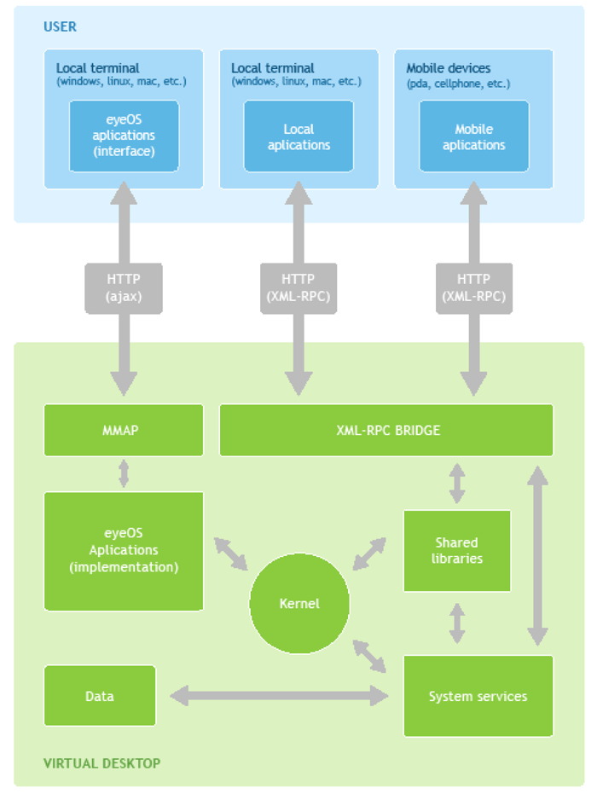

**Logical system operational flow**

**Architecture**

**Application domain**

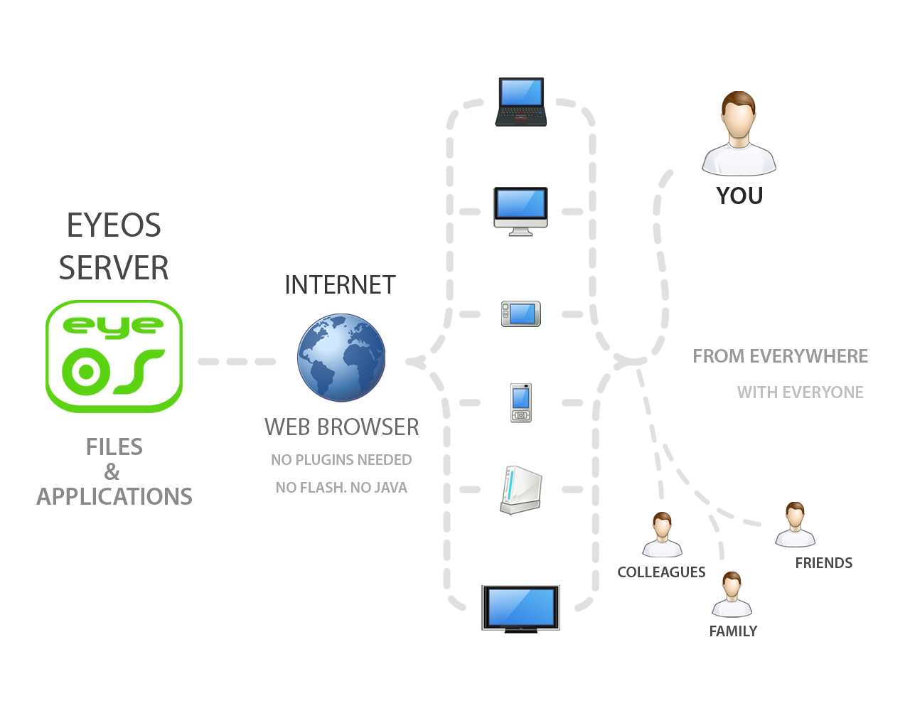

**Features of eyeos:**

**1.Managing Files**

* *Uploading multiple files simultaneously.*
* *File management and visual interface.*
* *Download entire folders .*
* *Photo viewer with slideshow.*

***2.Personal information manager (PIM)***

* *Multiple calendars.*
* *eyeContacts*

***3. Desktop***

* *Completely customizable.*
* *Themes.*

4.Office

* *Wordprocessor Spreadsheets.*
* *Presentations.*
* *Support for MS Office formats.*
* ***Advantages:***
* Portability
* Browser and Platform independent
* Availability.
* ***Disadvantages:***
* Safety
* Need for fast connection performance

**conclusion**

* It is designed for developers without experience to develop web applications.
* Requires only browser: A browser with java support is more than enough.
* Remote storage facility: Through the file browser you can store files over the internet and edit them as you want